President University



Report of Programming Assignment XXIII

Hitbox Detection

Computer Graphics and Animations

Nikita Chrissandha M (001201500031)

Predrika Br Ginting (001201500032)

Teuku Hilman Revanda (001201500038)

CIT 2 2015

2D Computer Graphics and Animation is a subject on Semester 7th of Information Technology lectured by Mr. Eddo Fajar Nugroho, S.Kom, MT.

# Introduction

# Basic Theory

## Pseudocode

# How to Use the Features in the Program

# The Background and Sprites Used in the Program

## Background

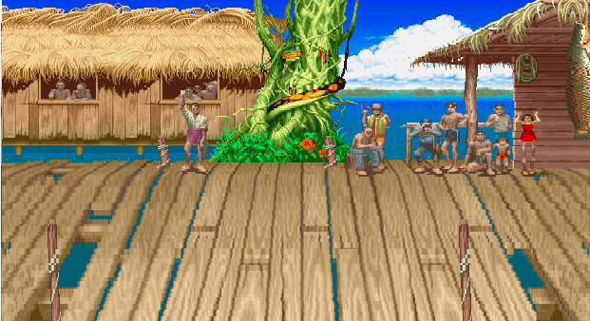Image that is used as background in this program is as follow.

## Sprites

### Introduction

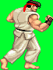

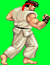

### Stand Facing Right



### Stand Facing Left



### Crouch



# The Actions for the Fighter Defined in the Program

# How the Background and Sprites are Represented in the Program

# How the Actions and Animations of the Sprites are Represented in the Program

# How the Hitboxes are Represented in the Program.

# How the Collision Detection Works in the Program.

# Evaluation

This application can be tested by many cases such as make the sprite walk, jump, crouch, etc. The evaluation is shown below.

# Work Log

The work log is extracted directly from Visual Studio’s Git Log History, which is also available publicly at <https://github.com/ichapredrika/PA12/commits/master>

|  |  |  |  |  |
| --- | --- | --- | --- | --- |
| No | Author | Date | Time | Commit Message |
| 1 |  | 11/10/2017 | 20:04:59 |  |

# Conclusion and Remarks

This program work as expected. Actually, doing this project is more fun than doing other projects.